Lesson Observation Form: Teacher___________________________________ Grade ________Date _____________
Please refrain from helping students. No side conversations with other observers, note what you wanted to say and save for the debriefing · Include the student name when possible · Focus on the students, not the teacher · Please limit your statements to what was noticed , not evaluative statements . Supply evidence.

Standard / Performance Expectation: Instructional Strategies included:

Lesson Instruction Observed: Student Responses

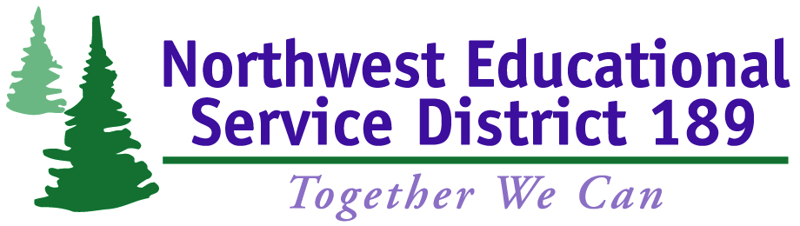
Lesson Closure: Formative Assessment Options:

Math & Science Collaborative Inquiry Project
Math & Science Collaborative Inquiry Project
Observer Guideline Handout
The role of the observer
Observers are not meant to be co-teachers. The purpose of the observers is to gather as much research as possible without disturbing the authenticity of said research. Essentially, it is as if you are viewing the lesson through a one way mirror; however, this mirror allows you to move around the classroom. Observers must see student work up close and record their findings in detail. As a researcher, the observer needs to view the lesson objectively – without judgment – suspending one’s personal beliefs about teaching and learning.
observer responsibilities during the study lesson
Respect the Natural Climate of the Classroom
- Eliminate side conversations during the lesson.
- Remain in the classroom during the entire lesson to capture the set up, flow and conclusion of the lesson.
- Do not block the students’ view of the whiteboards or visual aids.
- When the students are working individually or in groups, circle freely. Move to the back or side of the room for whole class discussions.
- Minimize interaction with students. Please refrain from teaching or assisting the children. Occasional interaction is permissible if done discreetly and with the purpose of understanding student thinking.
Become a Researcher
- Keep the goal of the lesson in mind.
- Use the lesson plan, seating chart, and work sheets to record your data.
- Study and record how students are collaborating.
- Take notes on individual student responses, using the students’ names where possible.
- Indicate how individual students construct their understanding through activities and discourse.
- Document the variety of solutions that individual students use to solve problems, including errors.
- Examine the teacher-student interaction; e.g. is the teacher attempting to call on all students?
- Document the type of student talk and student engagement.
Adapted from collaborative work of Global Education Resources LLC, Paterson Public School 2 (Paterson, NJ), Research for Better Schools, and the Northwest Regional Educational Laboratory Mathematics and Science Education Center

